EXCEL 2000
Lesson Notes
Lesson 3

Selecting Data

Selecting cells is a very important concept of a spreadsheet. We need to know how to reference the data in other parts of the spreadsheet. When entering your selection you may use the keyboard or the mouse. We can select several cells together if we can specify a starting cell and a stopping cell. This will select ALL the cells within this specified BLOCK of cells.

To select | Do this
Text in a cell | If editing in a cell is turned on, select the cell, double-click in it, and then select the text in the cell.  If editing in a cell is turned off, select the cell, and then select the text in the formula bar.  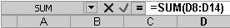
A single cell | Click the cell, or press the arrow keys to move to the cell.
A range of cells | Click the first cell of the range, and then drag to the last cell.
All cells on a worksheet | Click the Select All button.  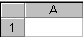  Click here
An entire row or column | Click the row heading or column heading.  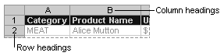

Formatting Data

- Changing font type and size
- Select whole cells or the specific text in a single cell that you want to format.
- In the Font box on the Formatting toolbar click the font you want.
Click here
- In the Font Size box, click the font size you want.
Click here
- Changing font style and alignment
- Select whole cells or the specific text in a single cell that you want to format.
- On the Formatting toolbar, click a button for the format you want.
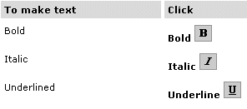
- Changing Text colour
- Select whole cells or the specific text in a single cell that you want to format.
- To apply the most recently selected color, click on the Formatting toolbar.
To apply a different color, click the arrow next to , and then click a color on the palette.
Click here
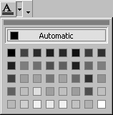

Adding or removing a currency symbol
- Select the cells you want to format.
- On the Format menu, click Cells, and then click the Number tab.
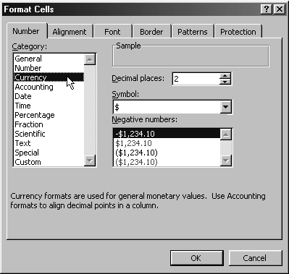
- In the Category list, click Currency.
- In the Symbol list, do ONE of the following:
  - To add a currency symbol, select the one you want.
  - To remove a currency symbol, click None.
Alternatively, click on .

Showing numbers as percentages
- Select the cells you want to format.
- On the Format menu, click Cells, and then click the Number tab.
- In the Category list, click Percentage.
Alternatively, click on .

Increasing or decreasing the number of decimal places shown
- Select the cells you want to format.
- On the Formatting toolbar, do one of the following:
  - To display fewer digits after the decimal point, click .
  - To display more digits after the decimal point, click .

Apply borders to cells
- Select the cells you want to add borders to.
- To apply the most recently selected border style, click on on the Formatting toolbar.
To apply a different border style, click the arrow next to , and then click a border on the palette.

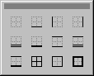
Click on one of these

