EXCEL 2000
Lesson Notes
Lesson 4

Inserting Columns & Rows

Inserting rows
- To insert a single row, click a cell in the row immediately below where you want the new row. For example, to insert a new row above Row 5, click a cell in Row 5.
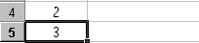
Click here
To insert multiple rows, select rows immediately below where you want the new rows. Select the same number of rows as you want to insert.
- On the Insert menu, click Rows.
- Inserting Columns
- To insert a single column, click a cell in the column immediately to the right of where you want to insert the new column. For example, to insert a new column to the left of Column B, click a cell in Column B.
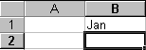
Click here
To insert multiple columns, select columns immediately to the right of where you want to insert the new columns. Select the same number of columns as you want to insert.

- On the Insert menu, click Columns.

Deleting Columns & Rows

When you delete cells, Microsoft Excel removes them from the worksheet and shifts the surrounding cells to fill the space. When you clear cells, you remove the cell contents (formulas and data), formats (including number formats, conditional formats, and borders), or comments, but you leave the blank cells on the worksheet.
- Select the cells, rows, or columns you want to delete.
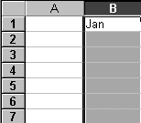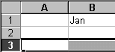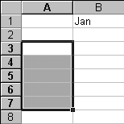
Select row
Select column
Select cells
- On the Edit menu, click Delete.
Surrounding cells shift to fill the space.

Changing Column width & row height

Changing column width
  - Drag the boundary on the right side of the column heading until the column is the width you want.
Drag here
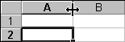
  - To change the column width for multiple columns, select the columns you want to change, and then drag a boundary to the right of a selected column heading.
  - To manually change the width, select the column, point to Column on the Format menu, click Width, and then enter a number.
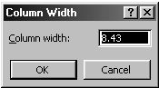
Type here
- Changing row height
  - Drag the boundary below the row heading until the row is the height you want.

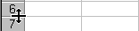
Drag here

  - To change the row height for multiple rows, select the rows you want to change, and drag a boundary below a selected row heading.

Using Functions
Spreadsheets have many Math functions built into them. Of the most basic operations are the standard multiply, divide, add and subtract. These operations follow the order of operations (just like algebra). Let's look at some examples.
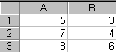

Operation | Symbol | Constant Data | Referenced Data | Answer
Multiplication | * | =5*6 | =A1*B3 | 30
Division | / | =8/4 | =A3/B2 | 2
Addition | + | =4+7 | =B2+A2 | 11
Subtraction | - | =8-3 | =A3-B1 | 5

Sum
Probably the most popular function in any spreadsheet is the SUM function. The Sum function takes all of the values in each of the specified cells and totals their values. The syntax is:
- =SUM(first value, second value, etc)
In the first and second spots you can enter any of the following (constant, cell, range of cells). (refer to above table)
- Blank cells will return a value of zero to be added to the total.
- Text cells cannot be added to a number and will produce an error.
Let’s use the table here for the discussion that follows:
We will look at several different specific examples that show how the typical function can be used! Notice that in A4 there is a TEXT entry. This has NO numeric value and cannot be included in a total.
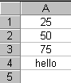
Example:
Function | Answer
=SUM(A1:A3) OR =SUM(A1+A2+A3) | 150
Use : to select a range of cells.
Using the barbecue sheet as an example :
- Select E23 in which you want the sum to be shown.
- Type the formula =SUM(E3:E22) in this cell or click to get the following:
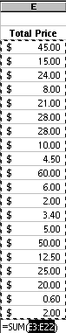
- Press ENTER to accept, ESC to cancel or click to accept and to cancel on the formula bar.
- The total amount needed for the barbecue is calculated.

Copying Formulas
Sometimes when we enter a formula, we need to repeat the same formula for many different cells. In the spreadsheet we can use the copy and paste command. The cell locations in the formula are pasted relative to the position we CUT them from.
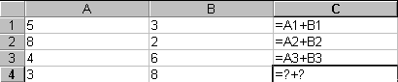
What should this be?
Cells information is copied from its relative position. In other words in the original cell (C1) the equation was (A1+B1). When we paste the function it will look to the two cells to the left. So the equation pasted into (C2) would be (A2+B2). And the equation pasted into (C3) would be (A3+B3).
Using barbecue sheet as an example, after calculating the total for one item:
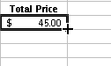
Click & drag here
- Place cursor on the lower right corner of E3 until a black crosshair is seen (see diagram above).
- Click and drag downwards.
- The formula will be copied to the cells below as well.

Average
There are many functions built into many spreadsheets. One of the first ones that we are going to discuss is the Average function. The average function finds the average of the specified data. (Simplifies adding all of the indicated cells together and dividing by the total number of cells.) The syntax is as follows.
- =Average (first value, second value, etc.)
Text fields and blank entries are not included in the calculations of the Average Function.
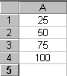
Example:
Function | Answer
AVERAGE(A1:A4) | 62.5
Using the barbecue sheet as an example :
- Select E24 in which you want the average to be shown.
- Type the formula =AVERAGE(E3:E22) in this cell.
- Press ENTER to accept, ESC to cancel or click to accept and to cancel on the formula bar.
- The amount each student has to pay is calculated.

Max
The next function we will discuss is Max (which stand for Maximum). This will return the largest (max) value in the selected range of cells.
- Blank entries are not included in the calculations of the Max Function.
- Text entries are not included in the calculations of the Max Function.

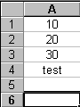
Example:
Function | Answer
MAX(A1:A5) | 30
Using the barbecue sheet as an example :
- Select E25 in which you want the max to be shown.
- Type the formula =MAX(E3:E22) in this cell.
- Press ENTER to accept, ESC to cancel or click to accept and to cancel on the formula bar.
- The most expensive food is calculated.

Min
The next function we will discuss is Min (which stands for minimum). This will return the smallest (Min) value in the selected range of cells.
- Blank entries are not included in the calculations of the Min Function.
- Text entries are not included in the calculations of the Min Function.
Example:
Function | Answer
MIN(A1:A5) | 10
Using the barbecue sheet as an example :
- Select E26 in which you want the min to be shown.
- Type the formula =MIN(E3:E22) in this cell.
- Press ENTER to accept, ESC to cancel or click to accept and to cancel on the formula bar.
- The least expensive food is calculated.

Count
The next function we will discuss is Count. This will return the number of entries (actually counts each cell that contains number data) in the selected range of cells.
- Blank entries are not counted.
- Text entries are NOT counted.
Example:
Function | Answer
COUNT(A1:A5) | 3
Using the barbecue sheet as an example :
- Select E27 in which you want the count to be shown.
- Type the formula =COUNT(E3:E22) in this cell.
- Press ENTER to accept, ESC to cancel or click to accept and to cancel on the formula bar.
- The number of items is calculated.

Using Absolute Referencing
If you don't want Excel to adjust references when you copy a formula to a different cell, use an absolute reference. For example, if your formula multiplies cell B4 with cell B1 (=B4*B1) and you copy the formula to another cell, Excel will adjust both references and your formula will turn out inaccurately for the other cells. This is because reference to B1 will change as the formula is copied.
You can create an absolute reference to cell B1 by placing a dollar sign ($) before the parts of the reference that do not change. To create an absolute reference to cell B1, for example, add dollar signs to the formula as follows:
=B4*$B$1
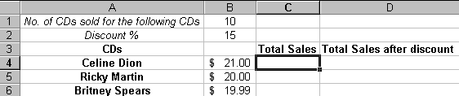
Type formula here

Wrong formula & results
Correct formula & results
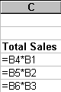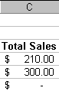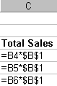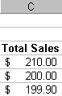
Using the reference sheet as an example, to calculate the Total Sales:
- Click C4.
- Type “=B4*$B$1”. (The $ is to create an absolute reference to B1 so that when the formula copies, it remains as it is)
- Copy this formula to the other cells. (Notice B1 remains as B1)
To calculate the Discount:
- Click D4.
- Type “=C4*$B$2”.
- Copy this formula to the other cells.
To calculate the Total Sales after Discount:
- Click E4.
- Type “=C4-D4”.
- Copy this formula to the other cells.

